Table of Contents
Intel® Workload Optimized Silicon - Aligning the Processor to Workload 1
Incorporating Workload Optimized Silicon in Purchase Decisions 2
Server Processor Selection Considerations 2
Applications and Workloads 3
Optimized Workloads 5
Summary 6
Resources 7

Intel® Workload Optimized Silicon - Aligning the Processor to Workload
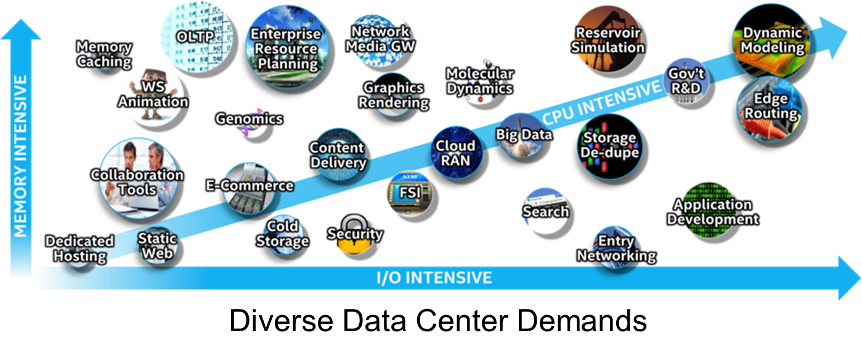
Organizations are using a diverse set of workloads. Optimizing each workload is a challenge for the data center. To meet this challenge, Intel has developed a number of different processor lines that meet the compute needs for these diverse server workloads and maximize performance and ROI.
Workloads requirements matched to the optimal mix of CPU, memory, I/O, and advanced technology built into the latest Intel processor provide peak performance. Traditionally, customers have standardized on servers configured to meet general-purpose workloads – sacrificing workload optimization for data center standardization. This standardized approach essentially allows diverse workloads to run on any server and attempts to maximize ROI by reducing the number of server configurations maintained in the data center. Adopting a workload-optimized technique when configuring servers in the data center can lower overall datacenter costs while providing several major advantages:
- Provides servers with the best CPU, memory and I/O performance for the workload improving performance and throughput for critical application
- Takes advantage of the advanced Intel technology built into the processor, further optimizing server performance for specific workloads
- Orchestrates with the most advanced Data Center Infrastructure Management (DCIM),the marriage of information technology and data center facility management disciplines, to optimize overall datacenter costs and performance

Incorporating Workload Optimized Silicon in Purchase Decisions
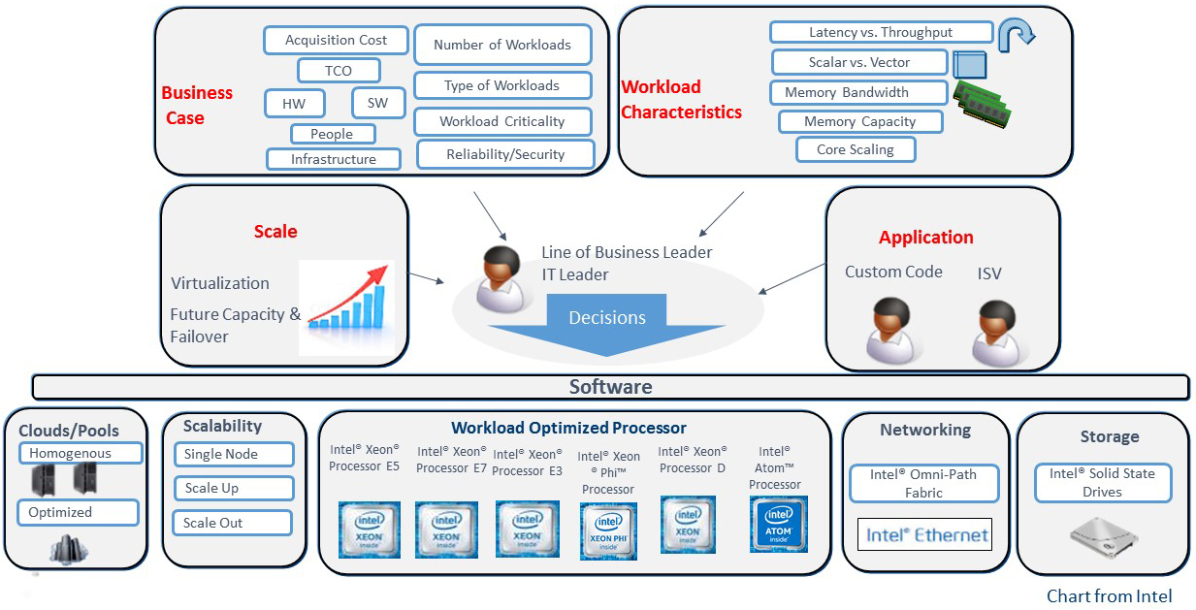
Of course, optimizing the processor is not the only consideration for customers in data center purchase decisions. Customers challenged to provide the best possible workload performance in the most cost effective manner measure new data center upgrades based upon return on investment (ROI).
Maximizing ROI using a workload-optimized approach focuses on four main areas:
- Business case – Acquisition costs of the hardware, software and services required, along with total cost of ownership (TCO) weigh against the business value of the server. Maximizing the workloads performed on a server increases its business value and lowers TCO.
- Workload characteristics – what is the technical profile of the workload? Does it scale with cores, is latency or throughput most important, require large memory or fast I/O to maximize performance? Configuring the server to maximize workload performance allows more work to be done on each server, lowering overall costs.
- Scale – How does the acquisition handle peak workloads and future growth? Planning growth within the server prevents the need for additional servers, lowering overall costs.
- Application considerations – Workload optimized silicon can also take advantage of the pricing models for application software. Minimizing the cores in a server can reduce the overall cost for applications priced per core. Maximizing processor frequency can optimize costs for applications priced per processor.
This paper focuses on workload characteristics and why decisions on which Intel Processor is chosen is so important.

Server Processor Selection Considerations
The majority of data center servers have four or eight sockets based on the Intel Xeon Processor E7 v4 product family or two socket servers based on the Intel Xeon® Processor E5 v4 product family.
However, the E5 v4 product family is broken down into six further segments. Each segment of processors contains useful characteristics that, when compared to the optimal characteristics of an application or workload, help select the optimal processor for the server. These segments are Basic, Standard, Low Power, Advanced, Frequency Optimized, and Segment Optimized.
Each of these processor and processor segments differ based upon the characteristics of the processors including:
- Number of cores
- Speed (frequency) of the processor
- Power the processor uses (in Watts)
- Amount of last level cache (LLC Cache)
- Speed of the Intel QuickPath® Interconnect (QPI) which is the ‘bus’ speed or the internal speed of the servers
- Speed of DDR4 memory
The following chart shows the characteristics of the E7 v4 family.
# Cores | Max Memory Speed | Intel® QPI | Last Level Cache | Thermal Design Power
Up to 24 | DDR4 2400 MHz | 3 X 9.6 GT/s | Up to 60 MB | 165W, 150W, 140W, 115W

The following chart shows the characteristics of the E5 v4 family.
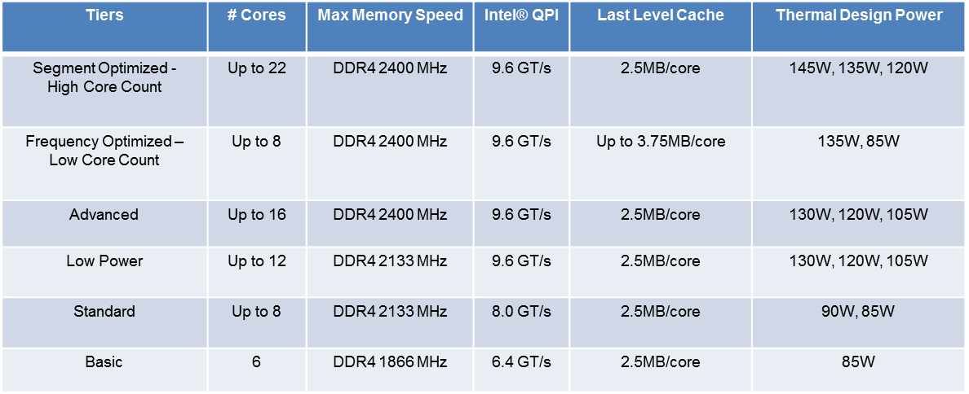

Applications and Workloads
Matching the processor to the application or workload will optimize performance of the server in the datacenter. While each environment is unique, the following can be used as a general guideline when selecting a processor.
Segment | Benefit
Cloud Workloads and Service Providers | New and increased orchestration and virtualization capabilities
Technical Computing | High core count, higher memory bandwidth, delivers flexible, scalable platforms with support for latest fabric solutions
Enterprise | High core count and new features to deliver workload optimized performance in a trusted secure environment
Storage Intensive | Performance for data deduplication, compression, tiering and thin provisioning.
Virtual Machine Environments | High core count, high memory bandwidth delivers performance for diverse workloads
Comms/Networking | Improved efficiency of security and compression workloads with IBM Quick Assist Acceleration

General guidelines are useful to match the general capabilities of a processor to a workload category. Intel has provided more specific guidelines based upon specific workload applications where Intel processors are deployed.
In the charts below, the dark green indicates where a processor is very applicable for a workload. The lighter green indicates where a processor is applicable for the workload. If a processor is not listed for a particular workload, it is not optimal for that workload.

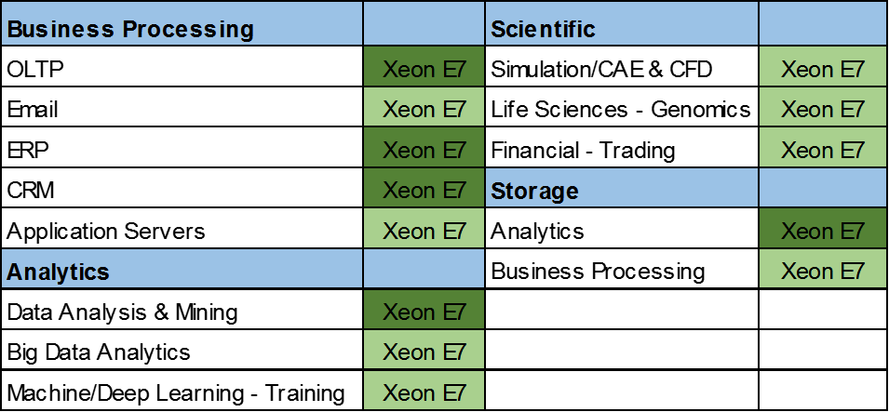
The following chart is for the Xeon E7 v4 family of processors:

The following chart addresses the E5 v4 family of processors. E5 indicates any E5 family member processor, HCC indicates a E5 High Core Count processor is preferred, and HF indicates a E5 High Frequency processor is preferred for those workloads.
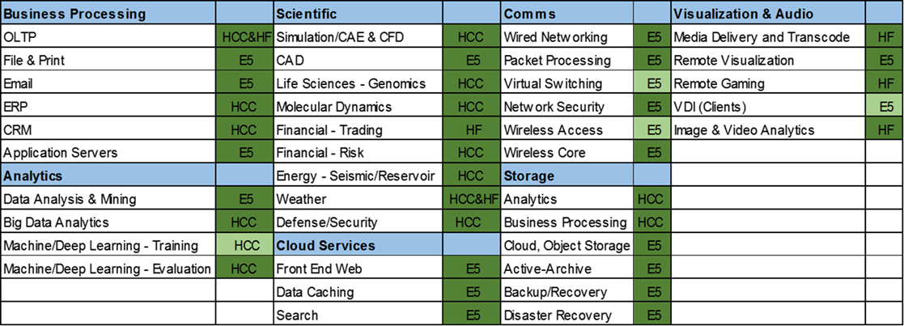

Optimized Workloads
The Intel Xeon Processor E7 v4 and E5 v4 family of processors provide a powerful array of performance features that, when matched with applications and workloads designed to take advantage of these features, significantly increase application performance and efficiency. These features are noteworthy because when servers are tuned to take full advantage of them, they can further increase performance for a workload.
Standard processor features for both families include:
- Advanced Features that optimize select workloads. These include Intel AVX2, Intel TSX, Intel RDT, Intel VMDQ and Intel VT technology. More information on these technologies is contained in the resource section.
- Intel Hyper-Threading Technology, which enables multiple threads to run on each core more efficiently and increases overall performance on threaded software, (available with most, but not all processors in this family).
- Intel Turbo Boost Technology, which enables the processor to run above its base operating frequency, allowing the processor to speed up to meet peak demands, (Available in all but the basic category in the E5 family).
The chart below lists a sampling of workloads that can benefit from workload-optimized silicon. Also listed are the Intel technology that enables it and a brief description of the technology. A more detailed description of the technology is in resources section.
Workload | Intel Technology | Description
Database Applications | Intel AVX2 | Doubles the number of floating point operations versus previous generations of AVX
Database Applications | Intel TSX | Boosts performance of multi-threaded workloads
Encrypted Workloads | Enhancements to Intel Xeon E5 V4 Processor Family | Improvements speed up the encryption/decryption process
Image Processing | Intel TSX | Boosts performance of multi-threaded workloads
Mixed Workloads | Intel AVX2 | Doubles the number of floating point operations versus previous generations of AVX
Online Transaction Processing (OLTP) | Intel TSX | Boosts performance of multi-threaded workloads
Software Defined Infrastructure | Intel RDT | Enhanced visibility and control
Virtualized Environments | Intel VMDQ | Allows more compute cycles to virtual machine performance
Virtualized Environments | Intel VT | Reduces overheads in cache, I/O and memory in VM hypervisors
Virtualized Environments | Intel VMDQ | Improves efficiency of the hypervisors virtual switch to the Intel Ethernet Controller
Web Servers | Intel TSX | Boosts performance of multi-threaded workloads

Summary
Customers select the best datacenter solution based on many factors, including the business case, the workload characteristics, the scale of the problem, which application software is being used, and planning for future growth to maximize the return on their data center investment. You need to help your customers add one more important factor in their datacenter decisions – move away from servers configured for general computing and adopting a workload-optimized model that leverages the performance features and characteristics of specific Intel Server processors to maximize their TCO and ROI.

Resources
- Intel Xeon Processor E7 v4 Product Family
- Intel Xeon Processor E5-2600 v4 Product Family
- Intel Xeon Processor E5-2600 v4 Product Family – Overview Animation
- Intel Xeon Processor E5-2600 v4 Product Family – Product Brief
- Intel VMDq Explanation (Video)
- Intel SR-IOV Explanation (Video)
- Web Resources about Intel TSX
- Intel RDT Web Page
- List of Intel Virtualization Technology (Intel VT) Supported Products

